EX:NO:06 E-TICKETING

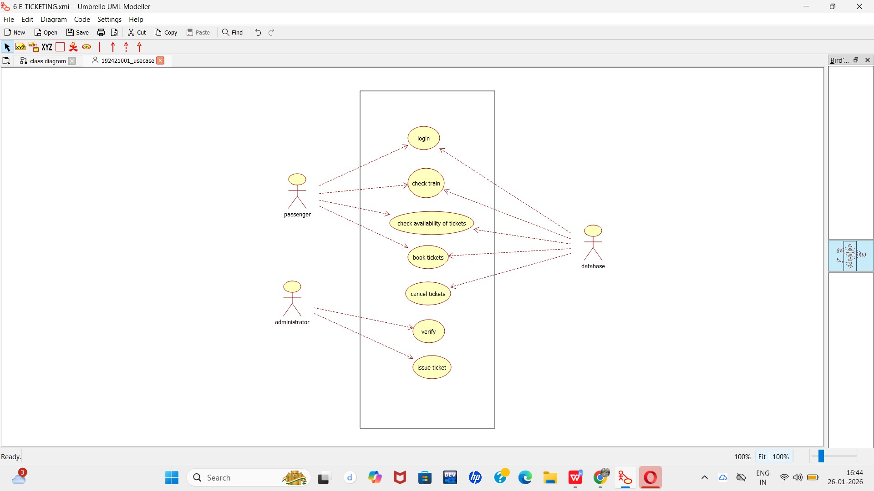
USE CASE DIAGRAM :

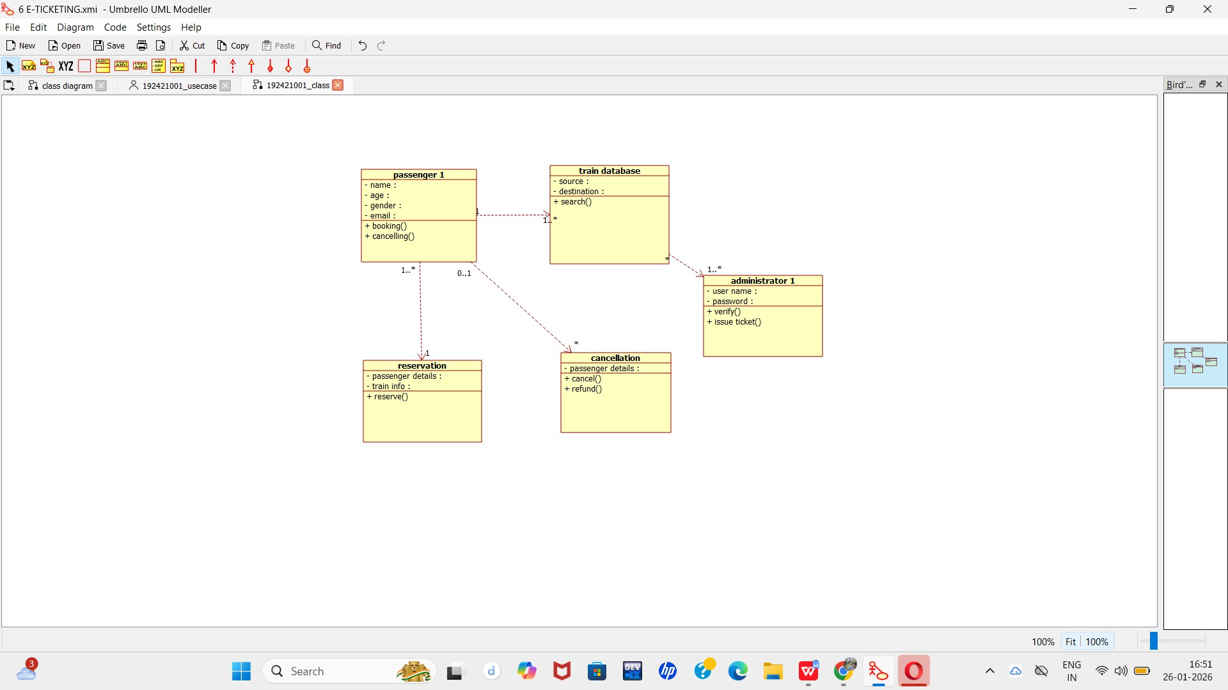
CLASS DIAGRAM :
ACTIVITY DIAGRAM:

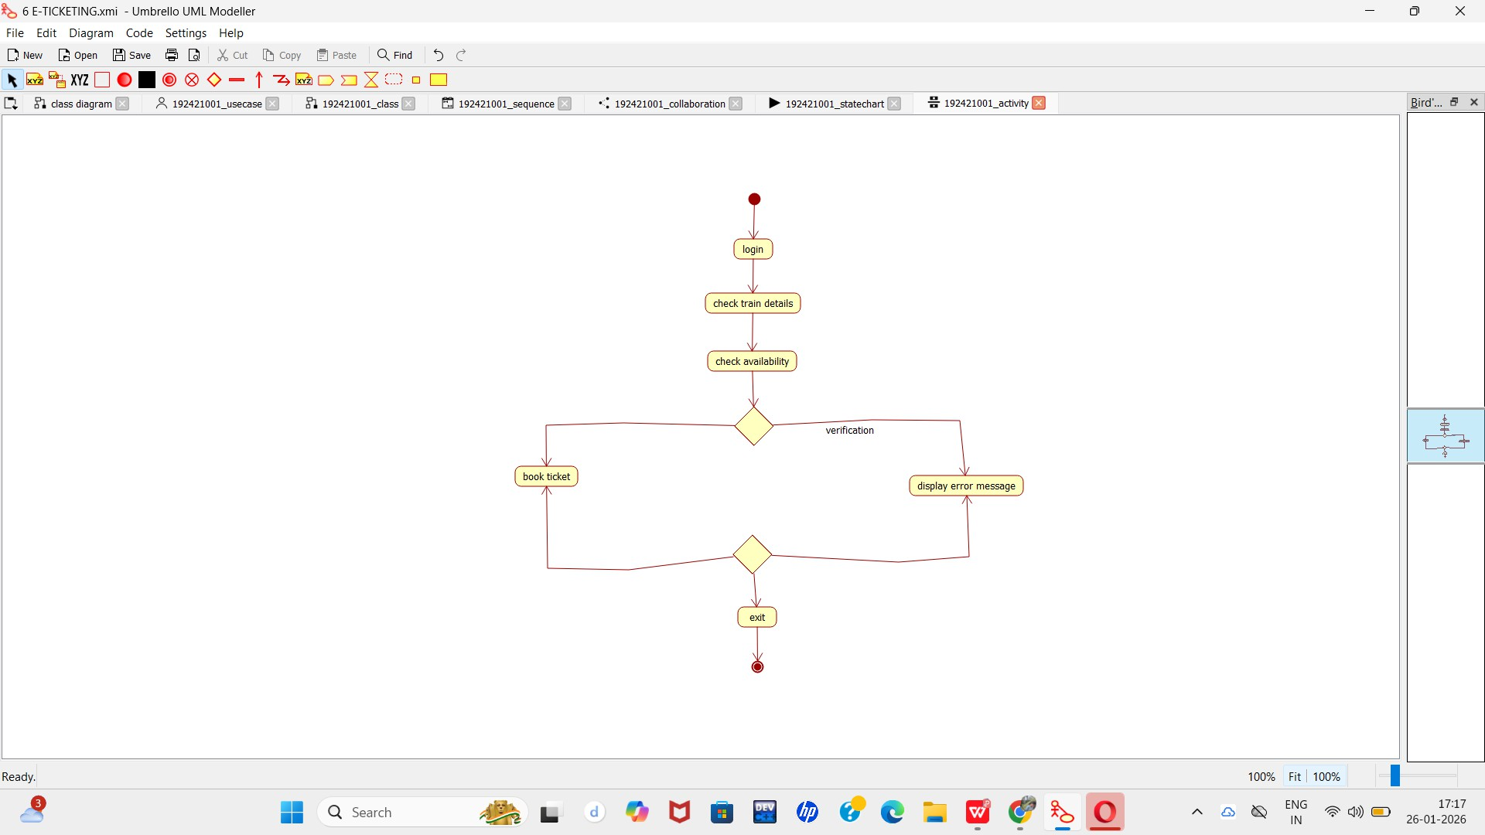

SEQUENCE DIAGRAM:

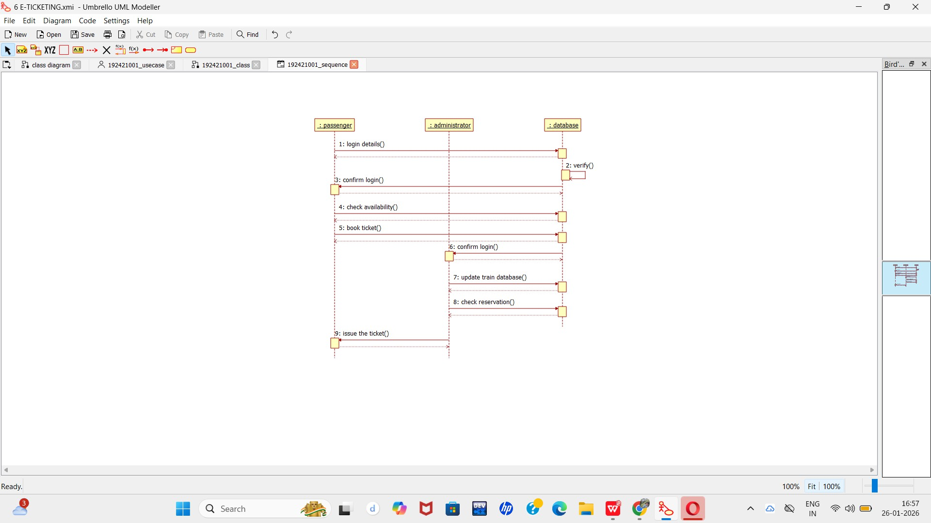

COLLABORATION DIAGRAM:
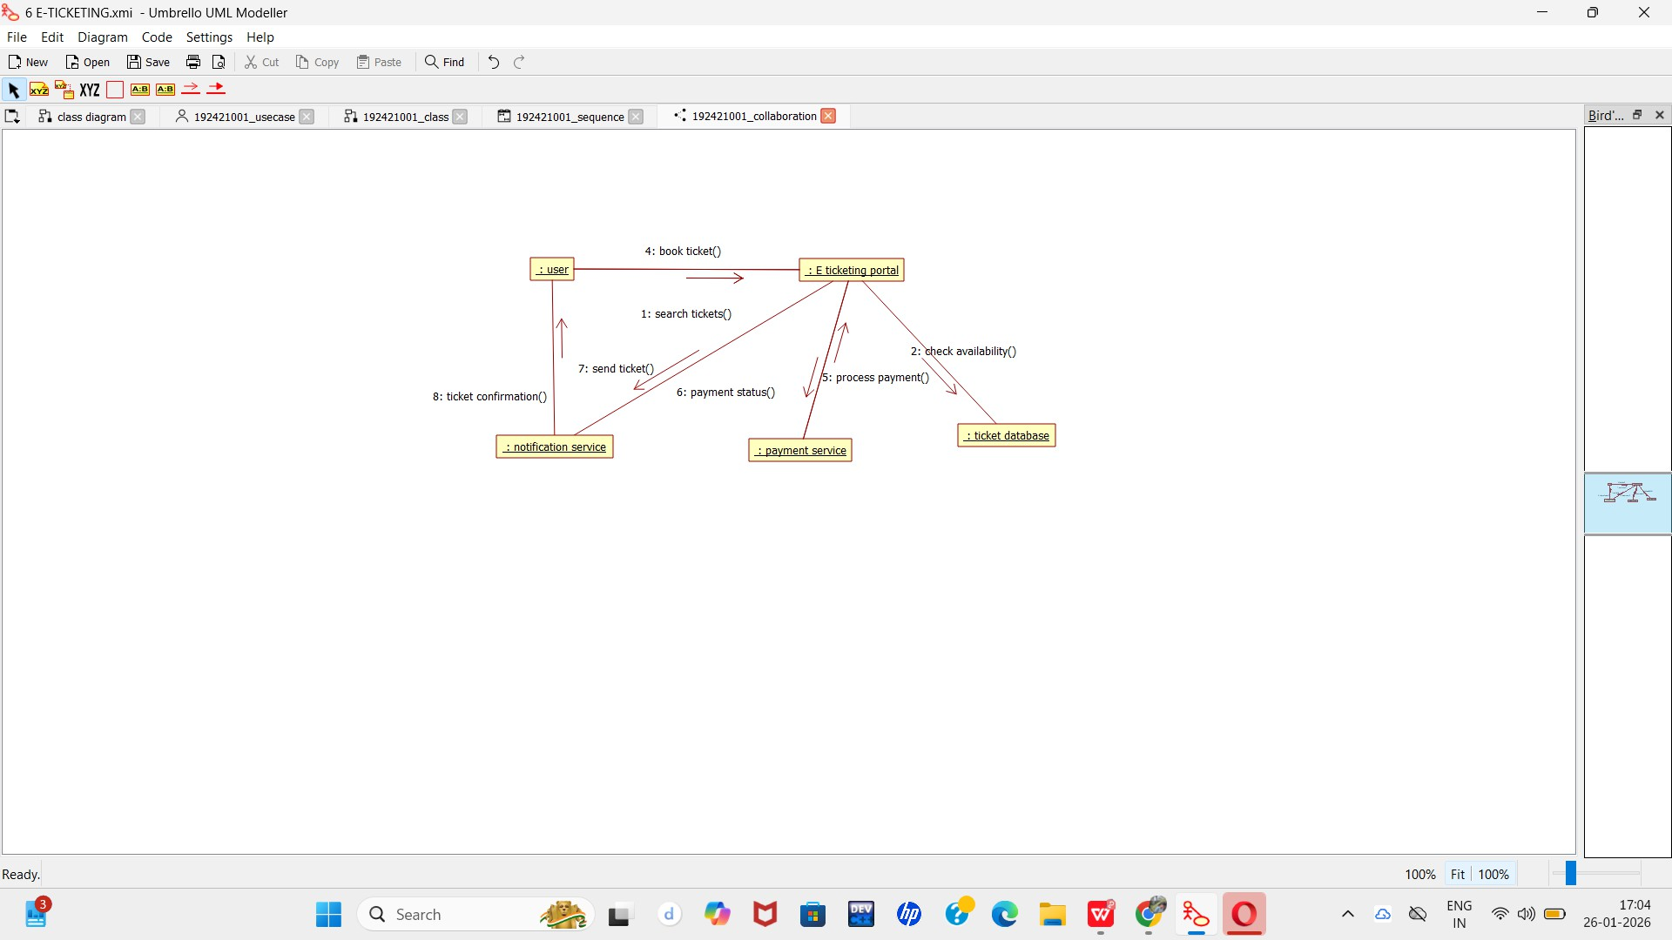

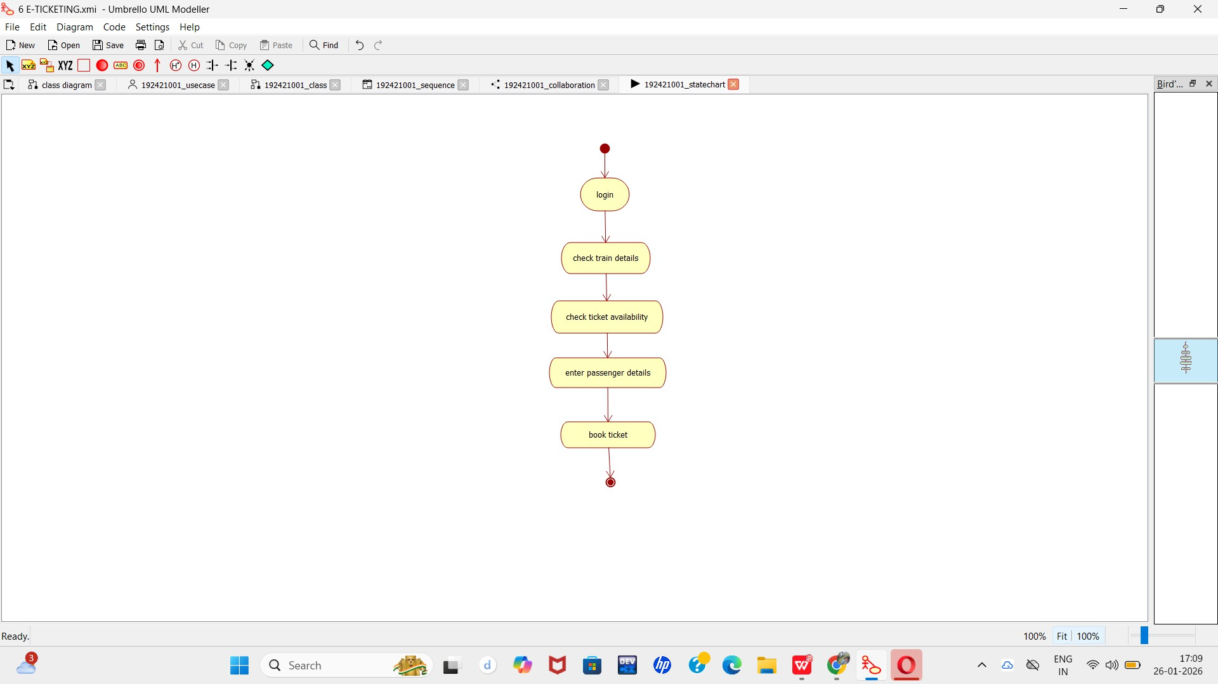
STATE
COMPONENT DIAGRAM:

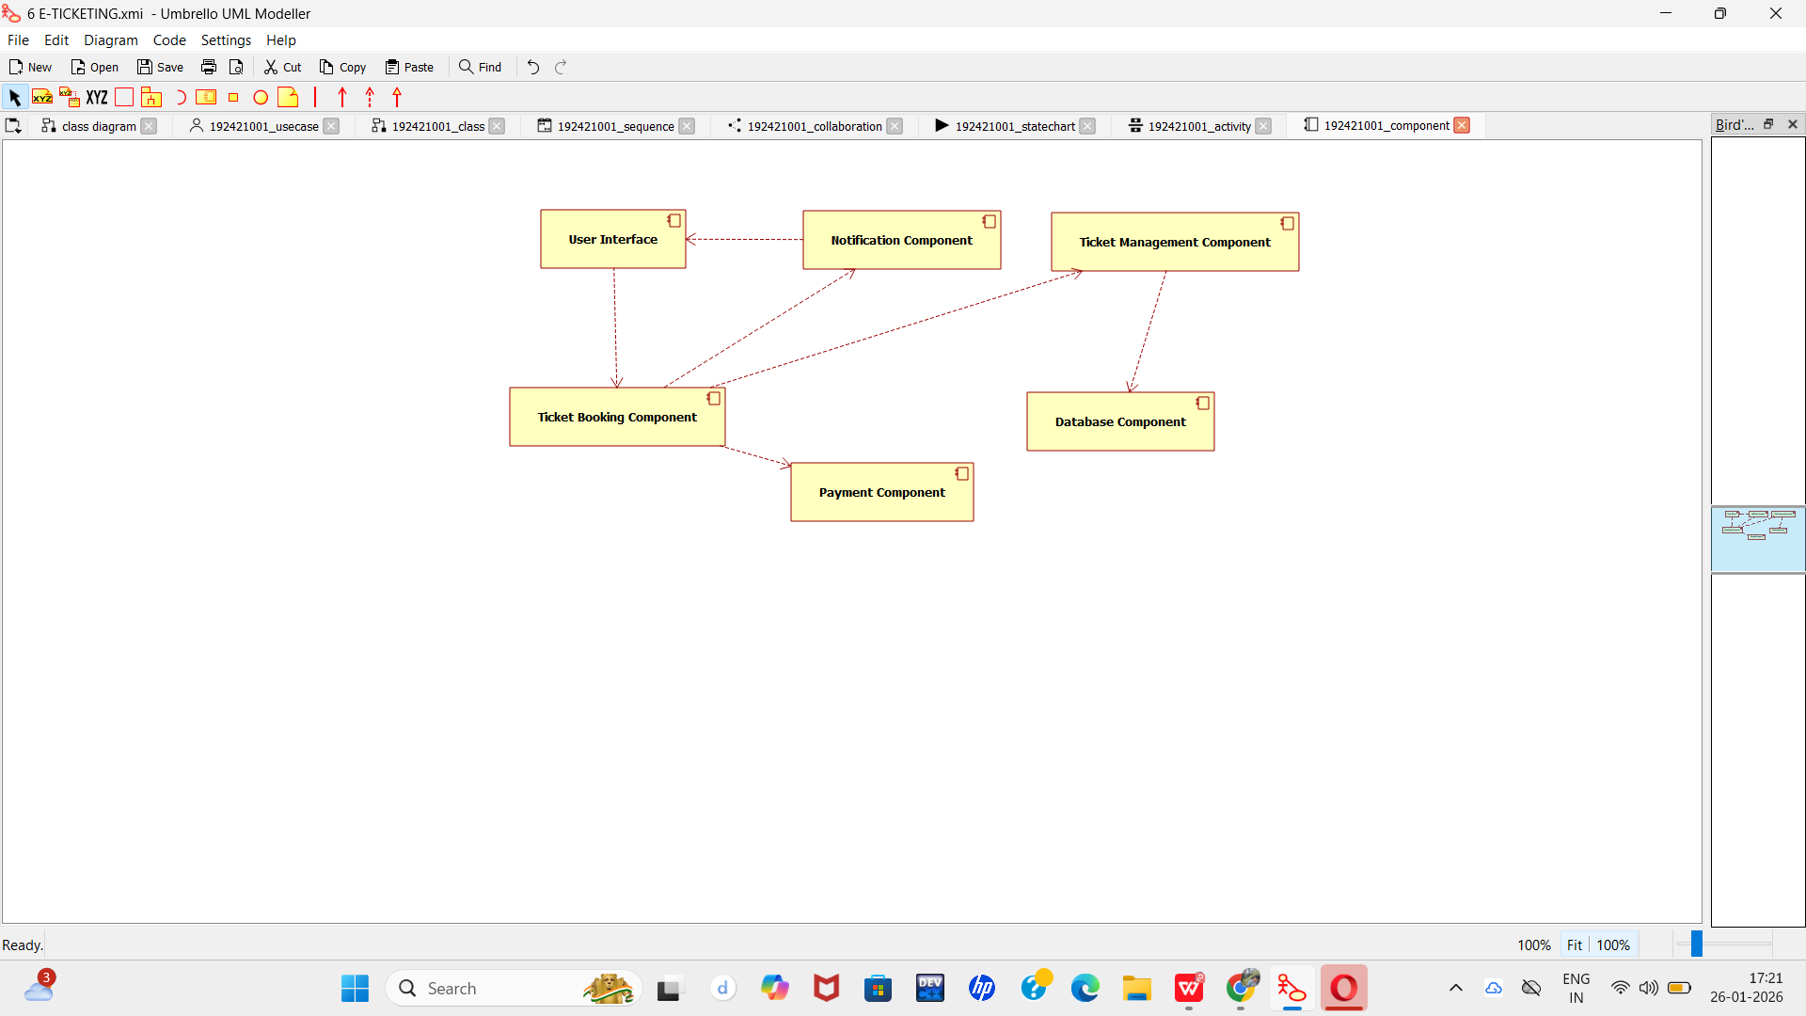

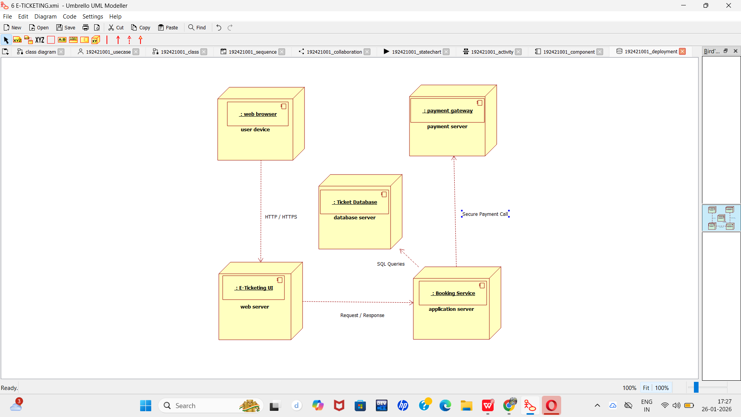
DEPLOYMENT DIAGRAM:
PACKAGE DIAGRAM:

